* **Name of the Activity:** One Day Workshop on New Process of Distribution of answer scripts
* **Date of the event**: 07.02.2023
* **Organizers:** Dept of Controller of Examinations, University of Kalyani, in association with Chakdaha College
* **Speakers:** Dr. Bimalendu Biswas, Controller of Examinations, University of Kalyani
* **Number of Participants:** 21
* **Outcome:** The one-day workshop on the new process of distributing answer scripts provided participants with valuable insights and practical knowledge about the evolving methods in the distribution of examination materials. In conclusion, the "One Day Workshop on New Process of Distribution of Answer Scripts" equipped participants with a comprehensive understanding of contemporary distribution techniques, fostering a transition towards more efficient, secure, and technology-driven approaches in handling examination materials.
* **Photographs of the Workshop:**

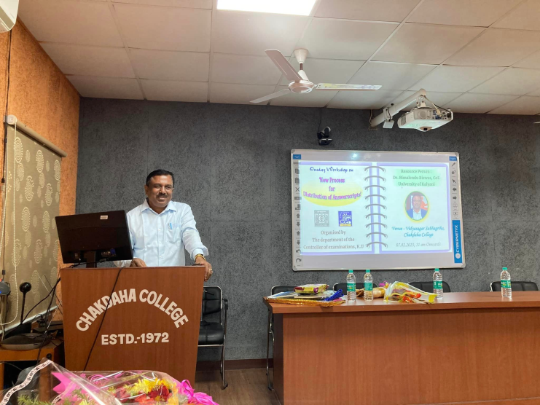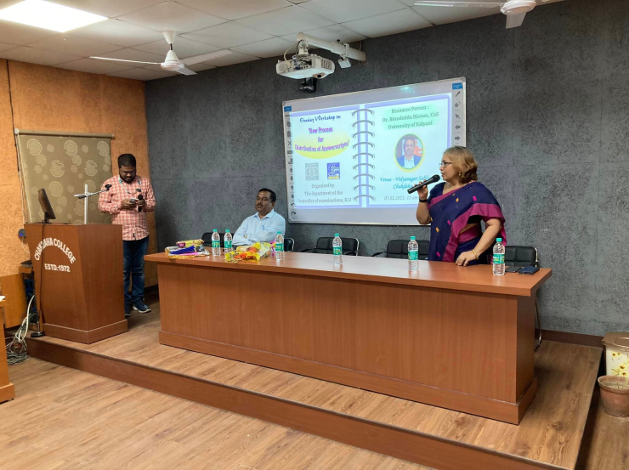

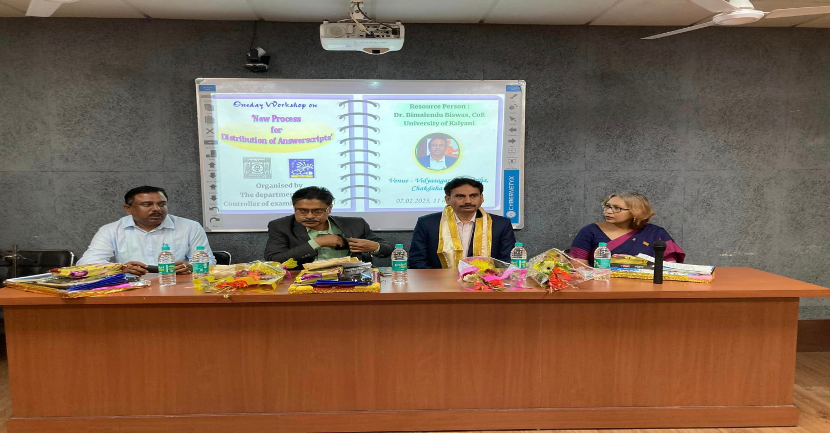

Attendance:

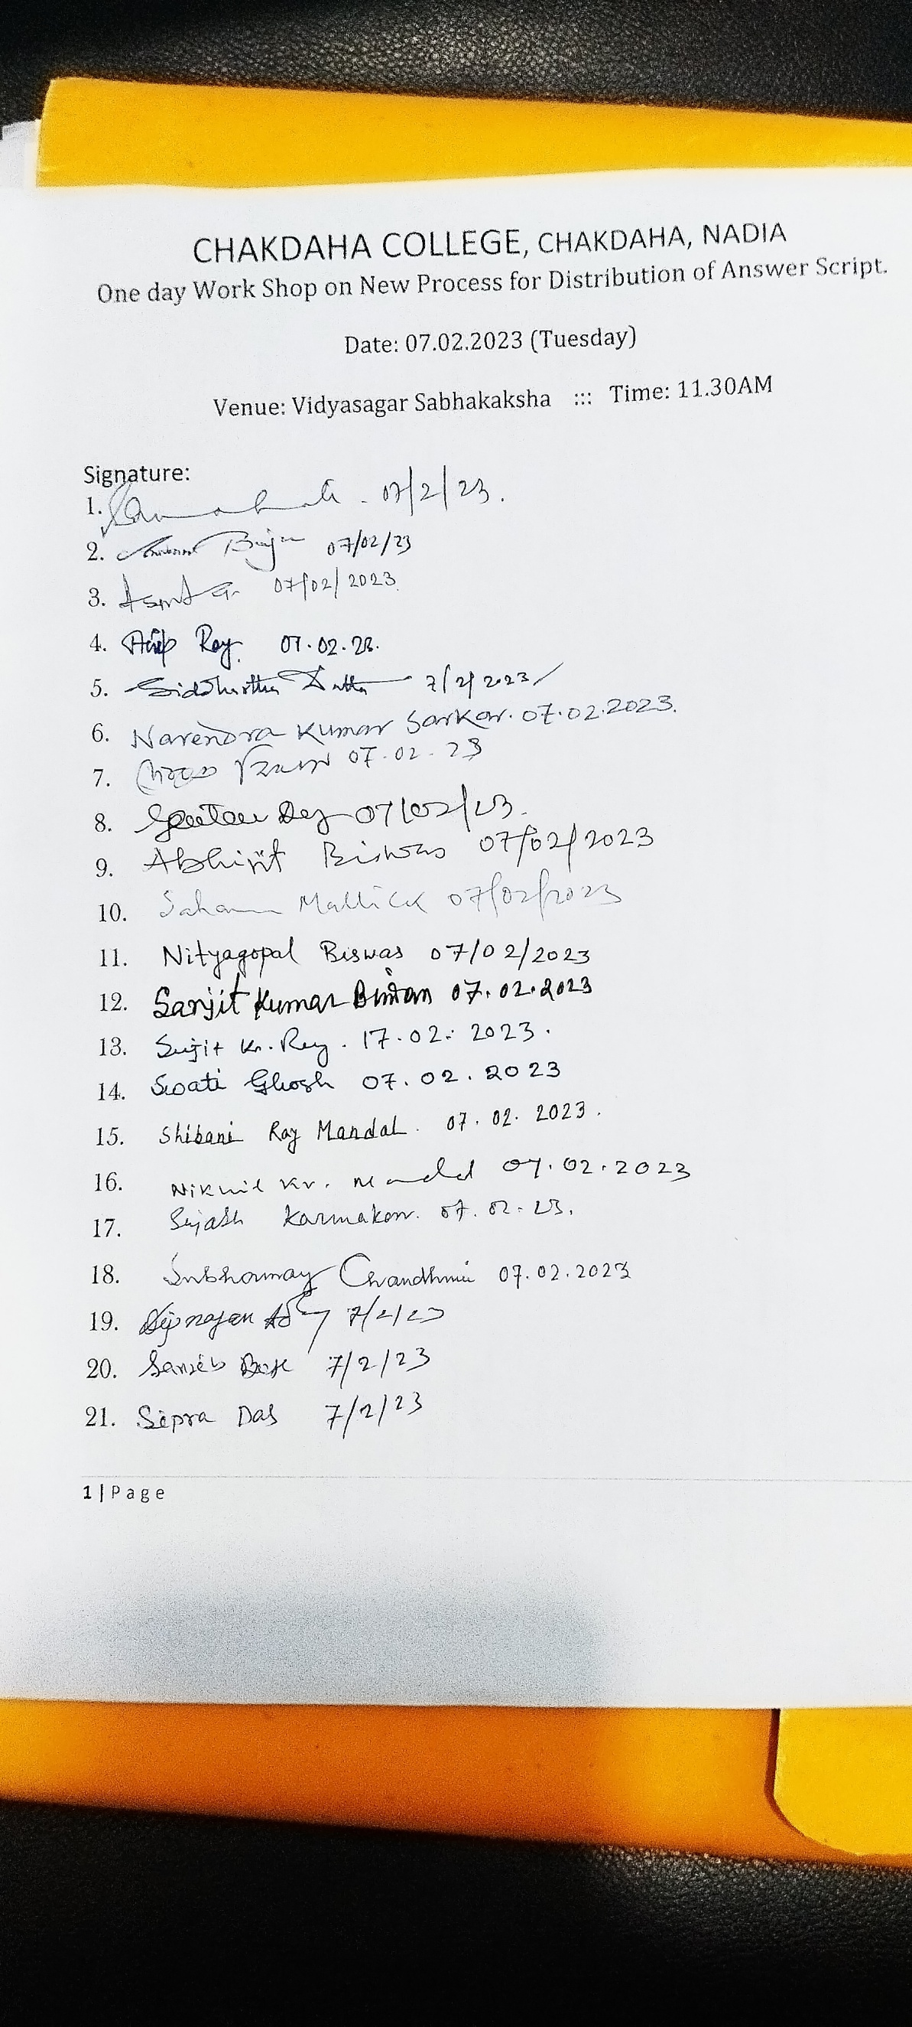

***Relevant Web Link:***

<https://www.facebook.com/photo/?fbid=583220033818765&set=pcb.583221617151940>